***Johnsons Landscaping LLC. Yes! We are a fully licensed***

***761 Bridgeton Pike, Monroeville NJ 08343 irrigation contractor!***

***(856) 343 – 4018 LICBP # 726067***

[***www.johnsonslandscapingllc.com***](http://www.johnsonslandscapingllc.com)

***LICBP # 726067***



OFFICE: 856-343-4018/ C: 856-498-4270

|  |  |  |  |
| --- | --- | --- | --- |
| *2025 Irrigation Service Contracts* | *Silver* | Gold | Platinum |
| *Spring Start Up* – pressurize irrigation main and laterals, visually inspect backflow preventer and rain sensor, program controller, check and adjust heads that are clearly out of alignment. \**Replace wireless rain sensor battery if needed.* | Checkmark | Checkmark | Checkmark |
| *Summer Check #1* – check and adjust heads that are clearly out of alignment, adjust zone run times to meet hot weather requirements, visually inspect system for leaks |  | Checkmark | Checkmark |
| *Summer Check #2* – check and adjust heads that are clearly out of alignment, adjust zone run times, visually inspect system for leaks, perform system assessment |  |  | Checkmark |
| *Backflow Preventer Test* – test check valve and air inlet to ensure backflow preventer is in good working condition |  |  | Checkmark |
| *Fall Winterization* – flush system of water using air compressor and make notes of any repairs that may be needed | Checkmark | Checkmark | Checkmark |
| *5% discount* on all labor and materials for repairs only |  | Checkmark |  |
| *10% discount* on all labor and materials for repairs only  5% discount on all labor and materials for new additions/upgrades |  |  | Checkmark |
| *Priority scheduling* – all services within each contract can be scheduled at the time of contract payment. Additional service calls needed throughout the season receive priority over noncontract customers. | Checkmark | Checkmark | Checkmark |

* **Spring Start Up** service to be performed during the months of April and May.
* **Summer Check** services to be performed during the months of June through September.
* **Fall Winterization** service to be performed during the months of October and November.
* A service call may be substituted for 1 summer check.
* Plans are transferable to the new home owner if you sell your home.

**Pricing for the 2025 Irrigation Service Contracts can be found in the tables below. Johnsons Landscaping is offering a discounted rate if payment is received before March 15th, 2025. Standard rates apply if paid after March 15th, 2025.**

|  |  |  |  |  |  |  |  |
| --- | --- | --- | --- | --- | --- | --- | --- |
| **Early Pay Before 3/15/2025** | **55+ Neighborhood Pricing Only** | **6 zones or less** | **7 to 9 zones** | **10-12 zones** | **13-15 zones** | **16-18 zones** | **19-21 zones** |
| **Silver** | $168.57 | $182.46 | $204.27 | $234.02 | $290.54 | $312.36 | $356.98 |
| **Gold** | $241.95 | $259.80 | $282.61 | $334.17 | $384.75 | $429.37 | $473.99 |
| **Platinum** | $381.77 | $393.67 | $451.18 | $533.49 | $629.67 | $691.15 | $735.78 |

**Please select One Option Below and complete all the current information. All prices include TAX.**

□I have circled the appropriate box above and included payment check #_______

□ I have circled the appropriate box above. Can you please send me an invoice via? (Email or mail)

□ **Please conduct PVB backflow preventer test for $110.89 (see next page for info)**

**Name: ______________________________________________**

**Address: _____________________________________________**

**Phone: ______________________________________________**

**Email: _______________________________________________**

**Number of Zones if known:** ____________________________

**Acceptance of Proposal- The above prices, specifications and conditions are satisfactory and are hereby accepted. You are authorized to do the work as specified. Payment will be made as outlined above. Please make payable to Johnsons Landscaping, LLC.**

Signature________________________________ Date of Acceptance: ___________

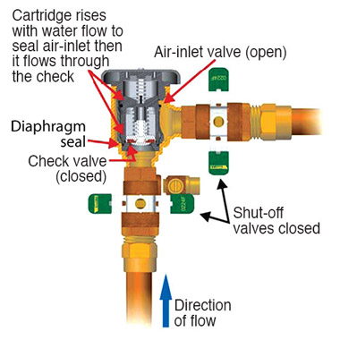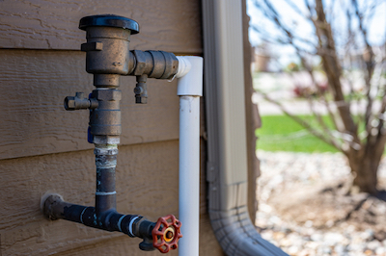

* Backflow preventers are installed to isolate cross connections between the potable water supply and contaminants. By law, NJAC 5:23-2.23(I) testable backflow preventers are required to be field-tested.
* Locations where cross connections between contaminants and the potable water supply are likely to be encountered include, but are not limited to, lawn sprinklers and irrigation systems, fire-protection systems, laboratories, chemical and industrial plants, boilers, hospitals, and waste-water treatment plants.
* Johnson’s Landscaping LLC is certified (BF-2023-070) to test your backflow preventer to ensure it is in working order. The cost for this service when combined with the purchase of a Silver or Gold 2025 Irrigation Service Contract is $110.89. **\*Already included in Platinum Contract**

***Ask us about upgrading your existing controller to a Wi-Fi based model. Wi-Fi controllers allow the user remote access to their controller from anywhere in the world via a smartphone or tablet, while providing up to 30% water savings by utilizing weather data from the internet to automatically adjust your system run times daily.***

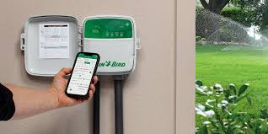

* Aside from taking care of all your irrigation system needs we are a full-service landscape company. We specialize in landscape design/maintenance and paver installations. We’ll bring life to your home!
* As always, we appreciate your loyalty and referrals!